**Title**

**Authors**

David Linnard Wheeler*1, Jeness Scott2,

Jeremiah Kam Sung Dung2, and Dennis Allen Johnson1

1. Department of Plant Pathology, Washington State University,

Pullman, WA, USA

2.Department of Botany and Plant Pathology, Oregon State University, Madras, OR, USA

**Correspondence:**

David L. Wheeler

Tel: 1+ (215) 880-3024

david.wheeler@wsu.edu

|  |  |
| --- | --- |
| **Section** | **Word count** |
| Main body (without abstract, references & legends) |  |
| Abstract |  |
| Introduction |  |
| Materials and Methods |  |
| Results |  |
| Discussion |  |
| Acknowledgements |  |
| **Figures & Tables** | **Number** |
| Number of Figures | 6 |
| Figures to be published in color | 6 |
| Tables | 2 |
| Supporting figures |  |

**Abstract**

The fungus *Verticillium dahliae* is an endophyte and pathogen of hundreds of plant species.The goal of this research was to identify *V. dahliae* genes associated with pathogenesis or endophytism and host genes associated with resistance or susceptibility. To accomplish this goal, the following hypotheses were tested: differences in gene expression exist between (i) symptomatic vs asymptomatic hosts during infection of *V. dahliae,* (ii) *V. dahliae* isolates that vary in aggressiveness on a host, and (iii) *V. dahliae* isolates across symptomatic and asymptomatic hosts. Potato, peppermint, and brown mustard plants were inoculated with two strains of *V*. *dahliae* that vary in aggressiveness. Whole plants were harvested 10 days post inoculation. Dual RNA-sequencing (RNA-seq) was completed.

* Number of genes
* Number of differentially expressed genes
* GO of all genes
* DEGs from:
  + Between symptomatic vs asymptomatic hosts (resistance vs susceptibility) within an isolate
  + *V. dahliae* isolates
    - between isolates (virulent or avirulent) within a host
    - between hosts (endophytic vs pathogenic) within an isolate
* Validation
* Impact and implications

**Introduction**

Members of the fungal genus *Verticillium* infect hundreds of plant species (Berlanger and Powelson, 2000). Individual isolates of the most economically destructive species of *Verticillium*, *V. dahliae* Kleb., (Pegg and Brady, 2002) can behave as both pathogens and endophytes on different hosts (Malcolm et al 2015; Wheeler et al. 2018). For example, some hosts, like brown mustard (*Brassica juncea* L.), are colonized but do not express detectable symptoms (Wheeler and Johnson, 2016). Other hosts, like potato (*Solanum tuberosum* L.) and peppermint (*Mentha* x *piperita* L.) are susceptible, express acute symptoms, and respond to infection with reductions in biomass (Dung et al. 2010; Johnson and Dung, 2010).

Successful management of these symptomatic reactions to *V. dahliae* could potentially be improved with more information about the genetic dynamics that govern symptomology. As of now, management of Verticillium wilts is difficult because *V. dahliae* produces survival structures called microsclerotia that can survive for 14 years (Wilhelm 1955), has a wide host range (Berlanger and Powelson, 2000), is sometimes (Tsror et al. 2005) but not always sensitive to soil-fumigants (Woodward et al. 2011), and resistance to the fungus is not always present in cultivars that possess other desirable traits (Johnson and Dung, 2010). Solutions to these management obstacles could conceivably be revealed by information about the genes that dictate biological processes in both *V. dahliae* and its hosts.

The authors are not the first to make this observation. Reports of transcriptional differences among isolates of *V. dahliae* and its hosts are abound. For example, differentially expressed genes (DEG) of *V. dahliae* isolates were detected by Duressa *et al*. 2013, Jin *et al*. 2019, and Jiménez-Ruiz *et al*. 2019 under different conditions. Similarly, DEGs from various hosts infected with *V. dahliae* have been reported by Guo *et al.* 2017, Sun *et al.* 2017, Tan *et al.* 2015. Finally, at least one study documented the transcriptomes of both *V. dahliae* and one of its hosts, *Arabidopsis*, during infection (Scholz  *et al.* 2018). Thus, gene expression profiles *V. dahliae* and its symptomatic hosts have received considerable attention among scientists.

In contrast, the authors are not aware of any studies that have documented the transcriptomes of multiple *V. dahliae* isolates and asymptomatic or symptomatic hosts during infection. Thus, the goal of this research is to fill this gap. To accomplish this goal, the asymptomatic host, brown mustard, and symptomatic hosts, including potato and peppermint, were separately inoculated with one of two isolates of *V. dahliae* that varied in aggressiveness. Dual RNA-seq was subsequently completed. DEGs were detected and validated. The results ….

**Materials and Methods**

To test the hypotheses stated above, a dual RNA-seq trial was completed and validated with quantitative reverse-transcriptase PCR (qRT-PCR). Each trial is described below.

**RNA seq trial**

The experimental design of the dual RNA-seq trial is described in **Figure 1**. The treatment structure was a 3 x 3 completely crossed factorial design. The first factor, host, consisted of three levels: Russet Burbank potato, Black Mitchum peppermint, and brown mustard ISCI 99. Similarly, the second factor, fungus, consisted of three levels: *Verticillium dahliae* isolate 653 (aggressive towards potato), *V. dahliae* isolate 111 (aggressive towards mint), and a water control. Each treatment was replicated 10 times and arranged in a randomized complete block design in a greenhouse.

Seeds of brown mustard, potato plantlets, and cuttings of peppermint with 2-4 nodes were planted in Turface® (Profile Products LLC, Buffalo Grove, IL) to enable easy harvesting. Plants were fertigated with 100 ppm of 20-10-20 NPK (Peters Professional, Summerville, SC) daily until all plants emerged from the Turface. Upon emergence of all plants, the Turface was either drenched with 100ml of 1 x 106 *V. dahliae* conidia/ml or sterile distilled water. After inoculation, plants were grown under a 15 hour/day photoperiod for 10 days.

Whole plants were harvested 10 days post inoculation (dpi). Harvested plants were subsequently flash frozen in liquid nitrogen, stored at -80°C for 1 week, and lyophilized. Once dried, whole plants were ground with a mortar and pestle. RNA was extracted with a modified version of Kumar *et al.* 2007 (**Supplementary document 1**). Estimates of RNA quality and quantity were determined by fragment analysis (Advanced Analytical Technologies Inc., Ankeny, IA) at Washington State University’s Center for Reproductive Biology, Molecular Biology and Genomics Core.

Samples of 3 biological replicate samples from each treatment were sent to Novogene corporations (Beijing, China) for library preparation and sequencing. In shor}|fter RNA qualification, mRNA was enriched with oligo (dT) beads, cDNA was synthesized and purified with end-repairs and the addition of poly (A) tails and ligation of adapters. Fragments were amplified and sequenced on an Illumina NovaSeq 6000 platform (Illumina, San Diego, CA).

For potato and *V. dahliae,* RNA fragments were mapped to each respective reference genome (potato: PRJNA63145; Xu *et al.* 2011; *V. dahliae*:PRJNA225532; Klosterman et al. 2011). For peppermint and brown mustard, RNA fragments were first filtered to remove reads with adapter contamination, reads comprised of 10% or more uncertain nucleotides, or reads comprised of 50% or more of low-quality nucleotides. After filtering, clean reads were assembled with Trinity (Grabherr *et al.* 2011). Redundant contigs were identified and removed with hierarchical clustering in Corset (Davidson and Oshlack, 2014). Unigenes were then selected as the longest transcript for each cluster.

Gene expression levels were determined and DEGs identified with the DESeq2 package version 1.26.0 (Love *et al.* 2014) in R version 3.6.2 (R Core Team (2019)). Reads with fewer than 1 count across samples were removed to expedite analysis. Contrasts between hosts within an isolate of *V. dahliae* and between isolates within a host were calculated after log fold change shrinkage (LFC) with the lfcShrink() function in R. *P-*values were adjusted to *q*-values = 0.001 to control for the False-Discovery Rate (FDR).

Functional annotation of unigenes was completed with seven databases: NR, NT, Pfam, KOG/COG, Swiss-Prot, KEGG, and GO. Alignment of unigenes to protein databases was accomplished with several softwares. Alignment of unigenes in NR, Swiss-Prot, and KOG was completed with Diamond 0.8.22 (Buchfink *et al.* 2015) with evalue thresholds of 1 × 10−5  for NR and Swiss-Prot and 1 × 10−3  for KOG. Alignment of unigenes in NT was completed with NCBI’s Blast 2.2.28+ (Altschul *et al.* 1990) with an e-value threshold of 1 × 10−5. Alignment of unigenes in Pfam was completed in HMMER (Eddy 2011) with an e-value threshold of 1 × 10−2 . Alignment of unigenes in GO was completed with results from Pfam and NR in Blast2GO v2.5 (Götz et al., 2008) with an e-value of 1 × 10−6. Finally, alignment of unigenes in KEGG was completed with the KAAS-KEGG Automatic Annotation Server with an e-value of 1 × 10−10 (Moriya *et al.* 2007).

**Validation trial**

**Results**

**RNA seq trial**

Summary statistics for reference-based transcriptome assemblies for potato and *V. dahliae* are presented in **Tables 1**. For potato, an average of 68% of total reads mapped back to the reference genome across all samples. For *V. dahliae,* an average of 0.1% of total reads mapped back to the reference genome across all samples.

Summary statistics for *de novo* based transcriptome assemblies for peppermint and brown mustard are presented in **Table 2**. For both peppermint and brown mustard, an average of 98% of raw reads were retained after read cleaning. Similarly, for both peppermint and brown mustard, 99% of total transcripts were identified as unique unigenes.

The number of DEGs varied across hosts and *V. dahliae* strains. Tables with samples of up to 10 DEGs for each contrast within each host and *V. dahliae* are provided as supplementary files (**Supplementary Tables 1-4**).

Differences in the total number of detected DEGs varied among treatments (**Figure 2**). For brown mustard, a total of 2,079 DEGs were detected (**Figure 2Aa**). Approximately 40% of these DEGs were identified from the contrast between plants infected with *V. dahliae* strain 653 and the non-inoculated control. Conversely, only about 23% of these DEGs were identified from the contrast between plants infected with *V. dahliae* strain 111 and the non-inoculated control. Comparatively fewer DEGs, about 1%, were identified from the contrast between plants infected with different strains of *V. dahliae.* Finally, no shared DEGs were detected in any of the contrasts for brown mustard (**Figure 2Aa**).

For potato, a total of 2,214 DEGs were detected (**Figure 2Ab**). As above, approximately, 47% of these DEGs were identified from the contrast between plants infected with *V. dahliae* strain 653 and the non-inoculated control. Further, about 19% of the DEGs were identified from the contrast between plants infected with *V. dahliae* strain 111 and the non-inoculated control. Like mustard, about 1% of DEGs were identified from the contrast between plants infected with different strains of *V. dahliae.* Finally, 0.1% of DEGs were shared among all of the contrasts for potato (**Figure 2Ab**).

For mint, a total of 1,588 DEGs were detected. (**Figure 2A**). Approximately 83% of these DEGs were identified from the contrast between plants infected with *V. dahliae* strain 111 and the non-inoculated control. Conversely, only about 1% of these DEGs were identified from the contrast between plants infected with *V. dahliae* strain 653 and the non-inoculated control. Still fewer DEGs, about 0.5%, were identified from the contrast between plants infected with different strains of *V. dahliae.* Finally, 0.25% of DEGs were shared among all of the contrasts for brown mint (**Figure 2Ac**).

Like the differences in total DEGs detected among treatments, gene expression patterns varied across hosts and *V. dahliae* strains (**Figure 3**). In general, patterns in gene expression were not systematic but were patchy within each host and *V. dahliae.* For example, brown mustard genes expressed in response to infection with *V. dahliae* strains varied from each other as much as each did from plants that were not inoculated (**Figure 3a**). Similarly, for potato, overt differences in gene expression between non-inoculated plants and those inoculated with either strain of *V. dahliae* represented only a subset of the total genes (**Figure 3b**). Exceptions to this observation are present, however. For example, potato plants inoculated with either strain of *V. dahliae* expressed lower levels of several genes (top rows of **Figure 3b**) compared to non-inoculated plants. Likewise for peppermint, there are several cases where plants inoculated with either of the *V. dahliae* strains exhibit gene expression patterns that are more similar to the non-inoculated plants than to the other strain of *V. dahliae*. Finally, for *V. dahliae*, the differences in gene expression between strains are eclipsed in magnitude by the differences observed between hosts. In other words, the strong vertical patterns in **Figure 3d** separate hosts, not strain differences within a host.

Patterns in DEGs were further investigated with volcano plots (**Figure 4A**). For the DEGs from host plants, the largest consistent differences in the magnitude of gene expression were observed in asymptomatic brown mustard plants. However, the single largest change in relative expression was detected in peppermint plants infected with *V. dahliae* strain 111 compared to inoculated plants. Further, the most statistically significant changes associated with the smallest *q*-values occurred in potato and peppermint plants inoculated with *V. dahliae* strain 111 compared to inoculated plants (**Figure 4A**).

For DEGs from *V. dahliae* strains, the largest differences in the magnitude of gene expression were observed in *V. dahliae* strain 111 recovered from peppermint and compared to mustard or potato (**Figure 4B**). Small but statistically significant differences in the magnitude of gene expression were detected within potato and peppermint, each inoculated with different *V. dahliae* strains. Moreover, the most statistically significant changes associated with the smallest *q*-values occurred in all comparisons between hosts and within a *V. dahliae* strain (**Figure 4B**).

The biological functions assigned to genes were similar for all hosts and *V. dahliae* (**Figure 5**). Most genes were involved in cellular and metabolic processes, binding and catalytic activity.

**Validation trial**

**Discussion**

**Acknowledgements**

**Tables**

**Table 1.** Summary statistics for reference-based transcriptome assembly of *Solanum tuberosum* and *Verticillium dahliae*. Included are the total number of reads generated, reads mapped to the reference genomes, reads that mapped to multiple locations, reads that mapped to only one location, and reads that did not map to the respective reference genome.

|  |  |  |
| --- | --- | --- |
| **Source** | ***Solanum tuberosum*** | ***Verticillium dahliae*** |
| Total reads | 65,720,887 ± 16,583,820 | 77,301,461 ± 6,069,398 |
| Mapped reads | 44,601,321 ± 11,149,227 | 103,065 ± 66,259 |
| Multiple mapped reads | 1,764,566 ± 428,612 | 439 ± 327 |
| Uniquely mapped reads | 42,836,754 ± 10,728,311 | 102,625 ± 65,971 |
| Unmapped reads | 21,119,565 ± 5,447,805 | 77,198,396 ± 6,074,812 |

**Table 2.** Summary statistics for *de novo* transcriptome assembly of *Mentha x piperita* and *Brassica juncea*. Included are the sequencing read counts, the number of reads recovered after filtering, the total number of clean nucleotides, the percentage of bases with correct nucleotide recognition greater than 99.9%, the total number of transcripts and unigenes, and the mean lengths of transcripts and unigenes.

|  |  |  |
| --- | --- | --- |
| **Source** | ***Mentha x piperita*** | ***Brassica juncea*** |
| Raw reads | 69,008,844 ± 17,431,082 | 65,190,911 ± 21,342,502 |
| Clean reads | 67,599,600 ± 17,071,506 | 63,754,238 ± 20,863,378 |
| Clean nucleotides (G) | 10 ± 2 | 10 ± 3 |
| Q30 (%) | 96 ± 0.1 | 95 ± 2 |
| Number of transcripts | 266,580 | 223,003 |
| Mean length of transcripts (nt) | 937 | 790 |
| Number of unigenes | 266,009 | 222,364 |
| Mean length of unigenes (nt) | 684 | 792 |

**Figures**

**Figure 1.** The treatment structure for this experiment was a 3 x 3 completely crossed factorial design. The first factor, host, consisted of three levels: brown mustard (a), potato (b), and peppermint (c). Likewise, the second factor, fungus, consisted of three levels: *Verticillium dahliae* isolate 653 (black), *V. dahliae* isolate 111 (red), and a water control (blue). Each treatment was replicated 10 times and arranged in a completely randomized block design.

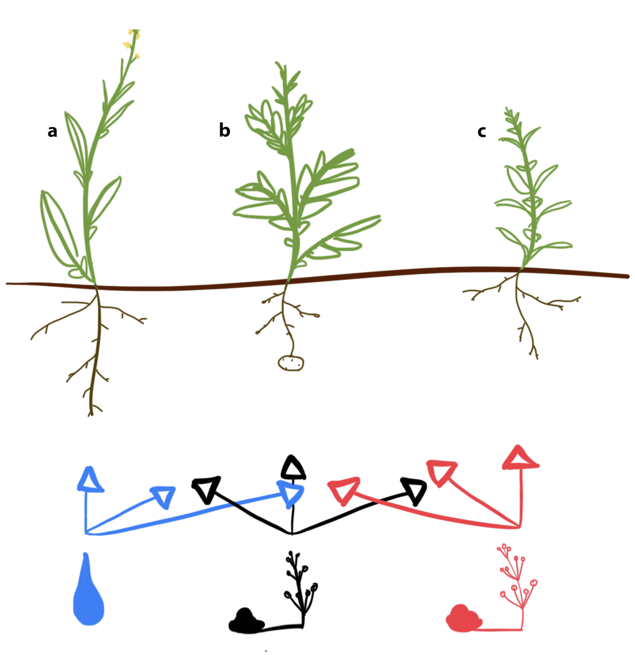

**Figure 2.** Comparisons of differentially expressed genes (DEGS) between (**A**): brown mustard (a), potato (b), and peppermint (c) infected with *Verticillium dahliae* isolate 653 and non-inoculated control (pink), *V. dahliae* isolate 111 and non-inoculated control (blue), and between *V. dahliae* isolates 653 and 111 (orange) and (**B**): *V. dahliae* isolates recovered from each host. Numbers within each venn diagram represent the shared number of DEGs between comparisons.

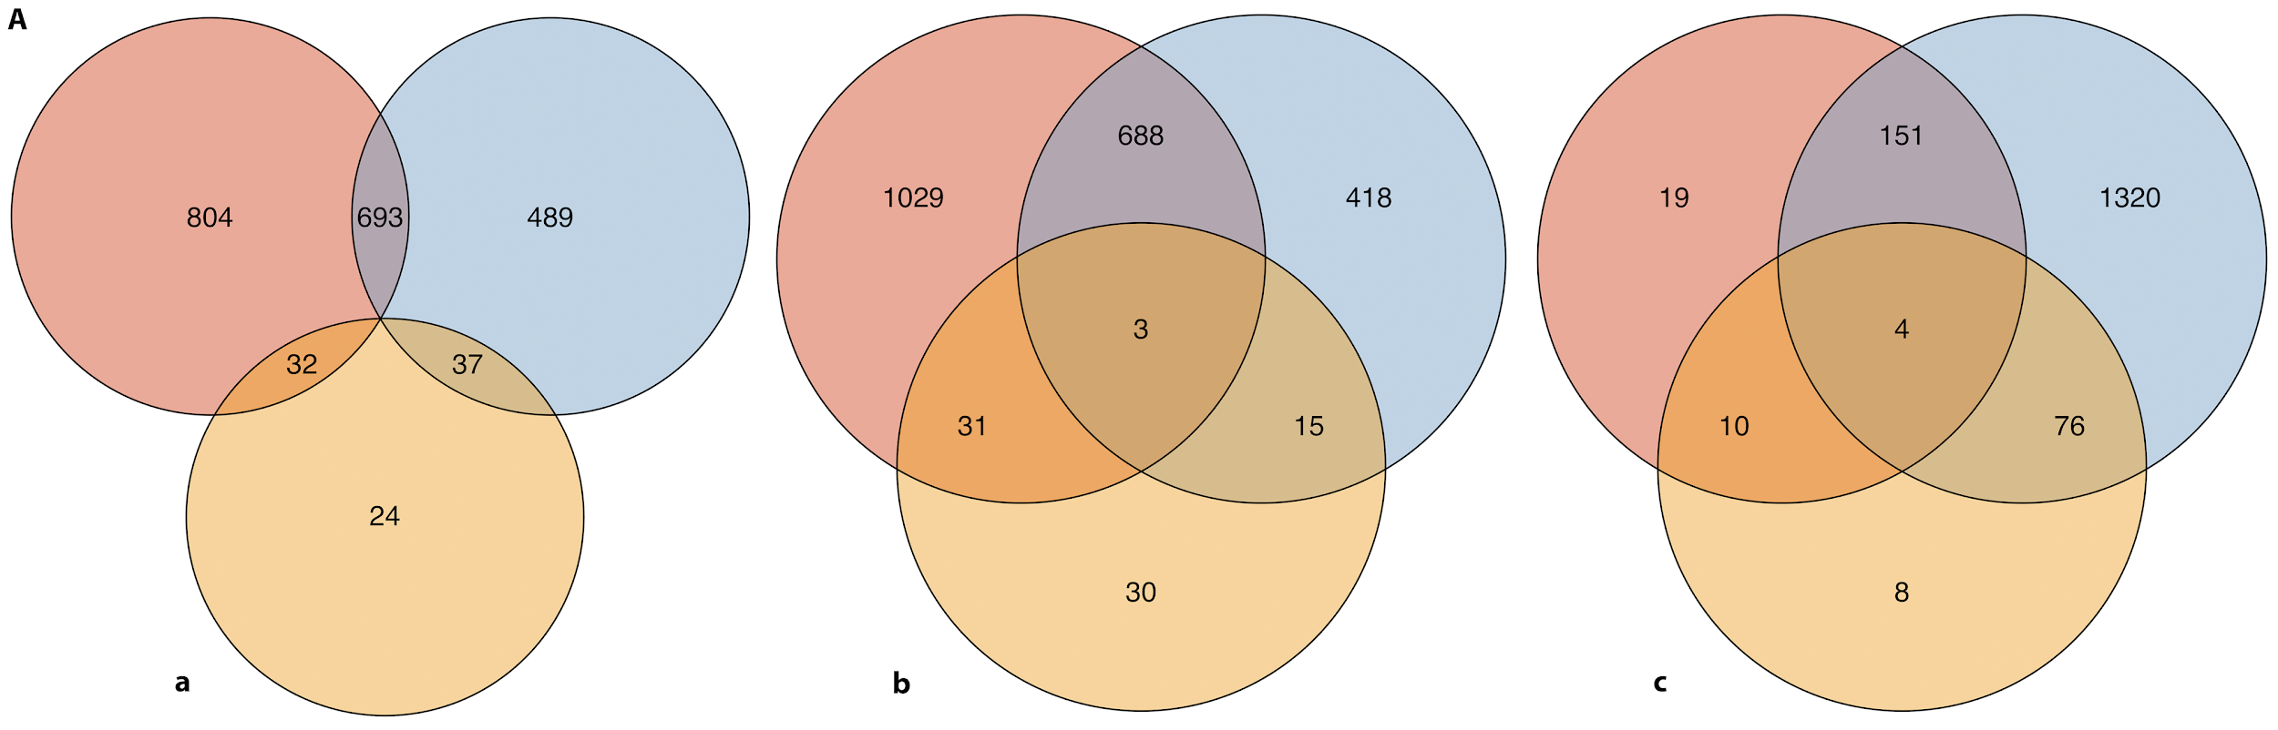

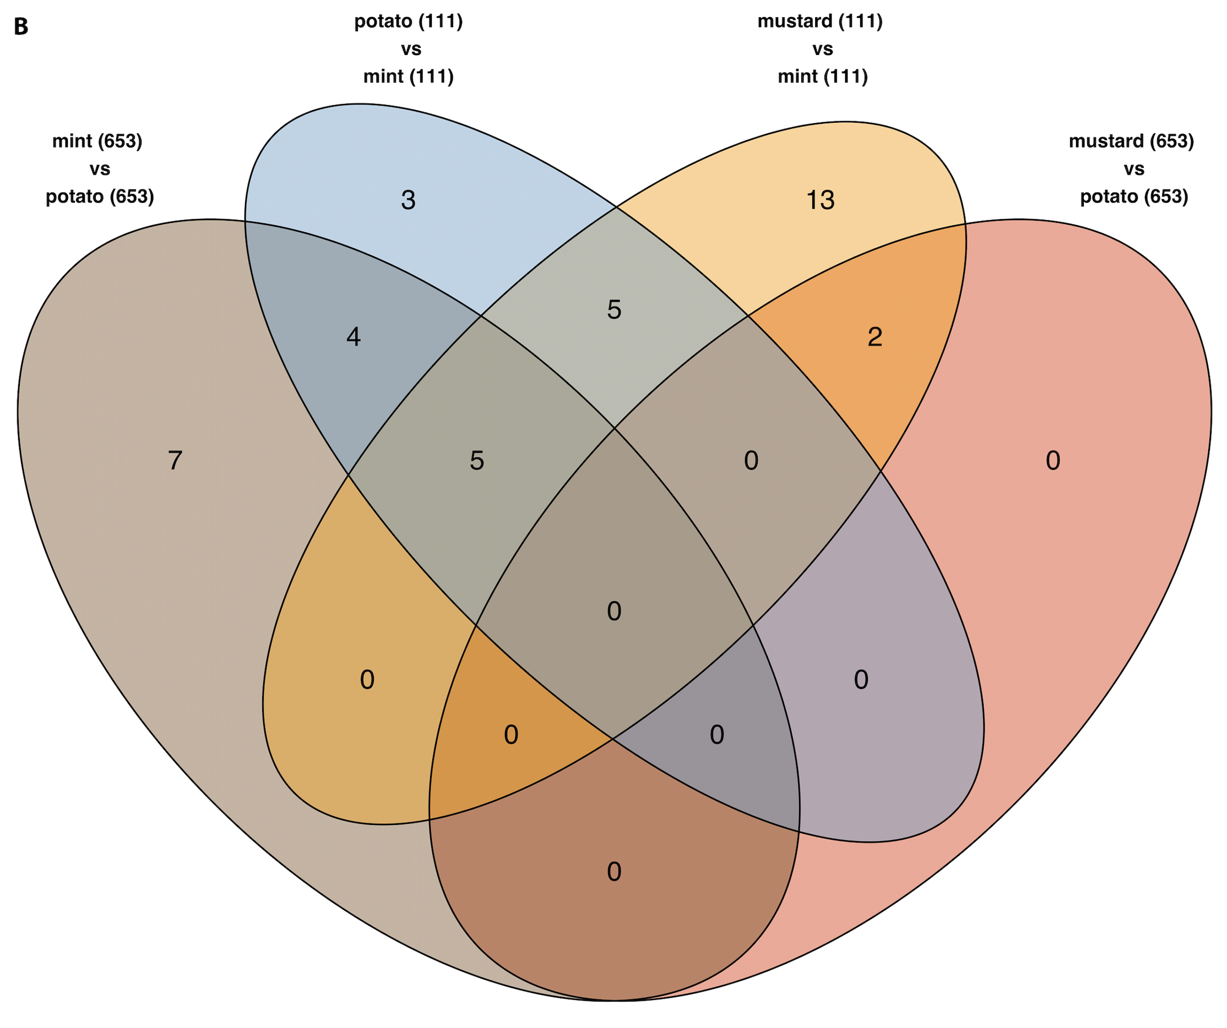

**Figure 3.** Log fold change of DEGs from plants (**A**) and *Verticillium dahliae* isolates (**B**) as a function of the mean number of normalized counts. Panel (**A**) presents MA plots for brown mustard (a), potato (b), and peppermint (c) plant genes expressed in plants infected with *Verticillium dahliae* isolate 653 vs. the non-inoculated control, *V. dahliae* isolate 111 vs. the non-inoculated control, and *V. dahliae* isolate 111 vs. *V. dahliae* isolate 653. Baseline controls for the last column depend on the host and are labeled accordingly. Panel (**B**) presents MA plots for *V. dahliae* genes expressed in different hosts.

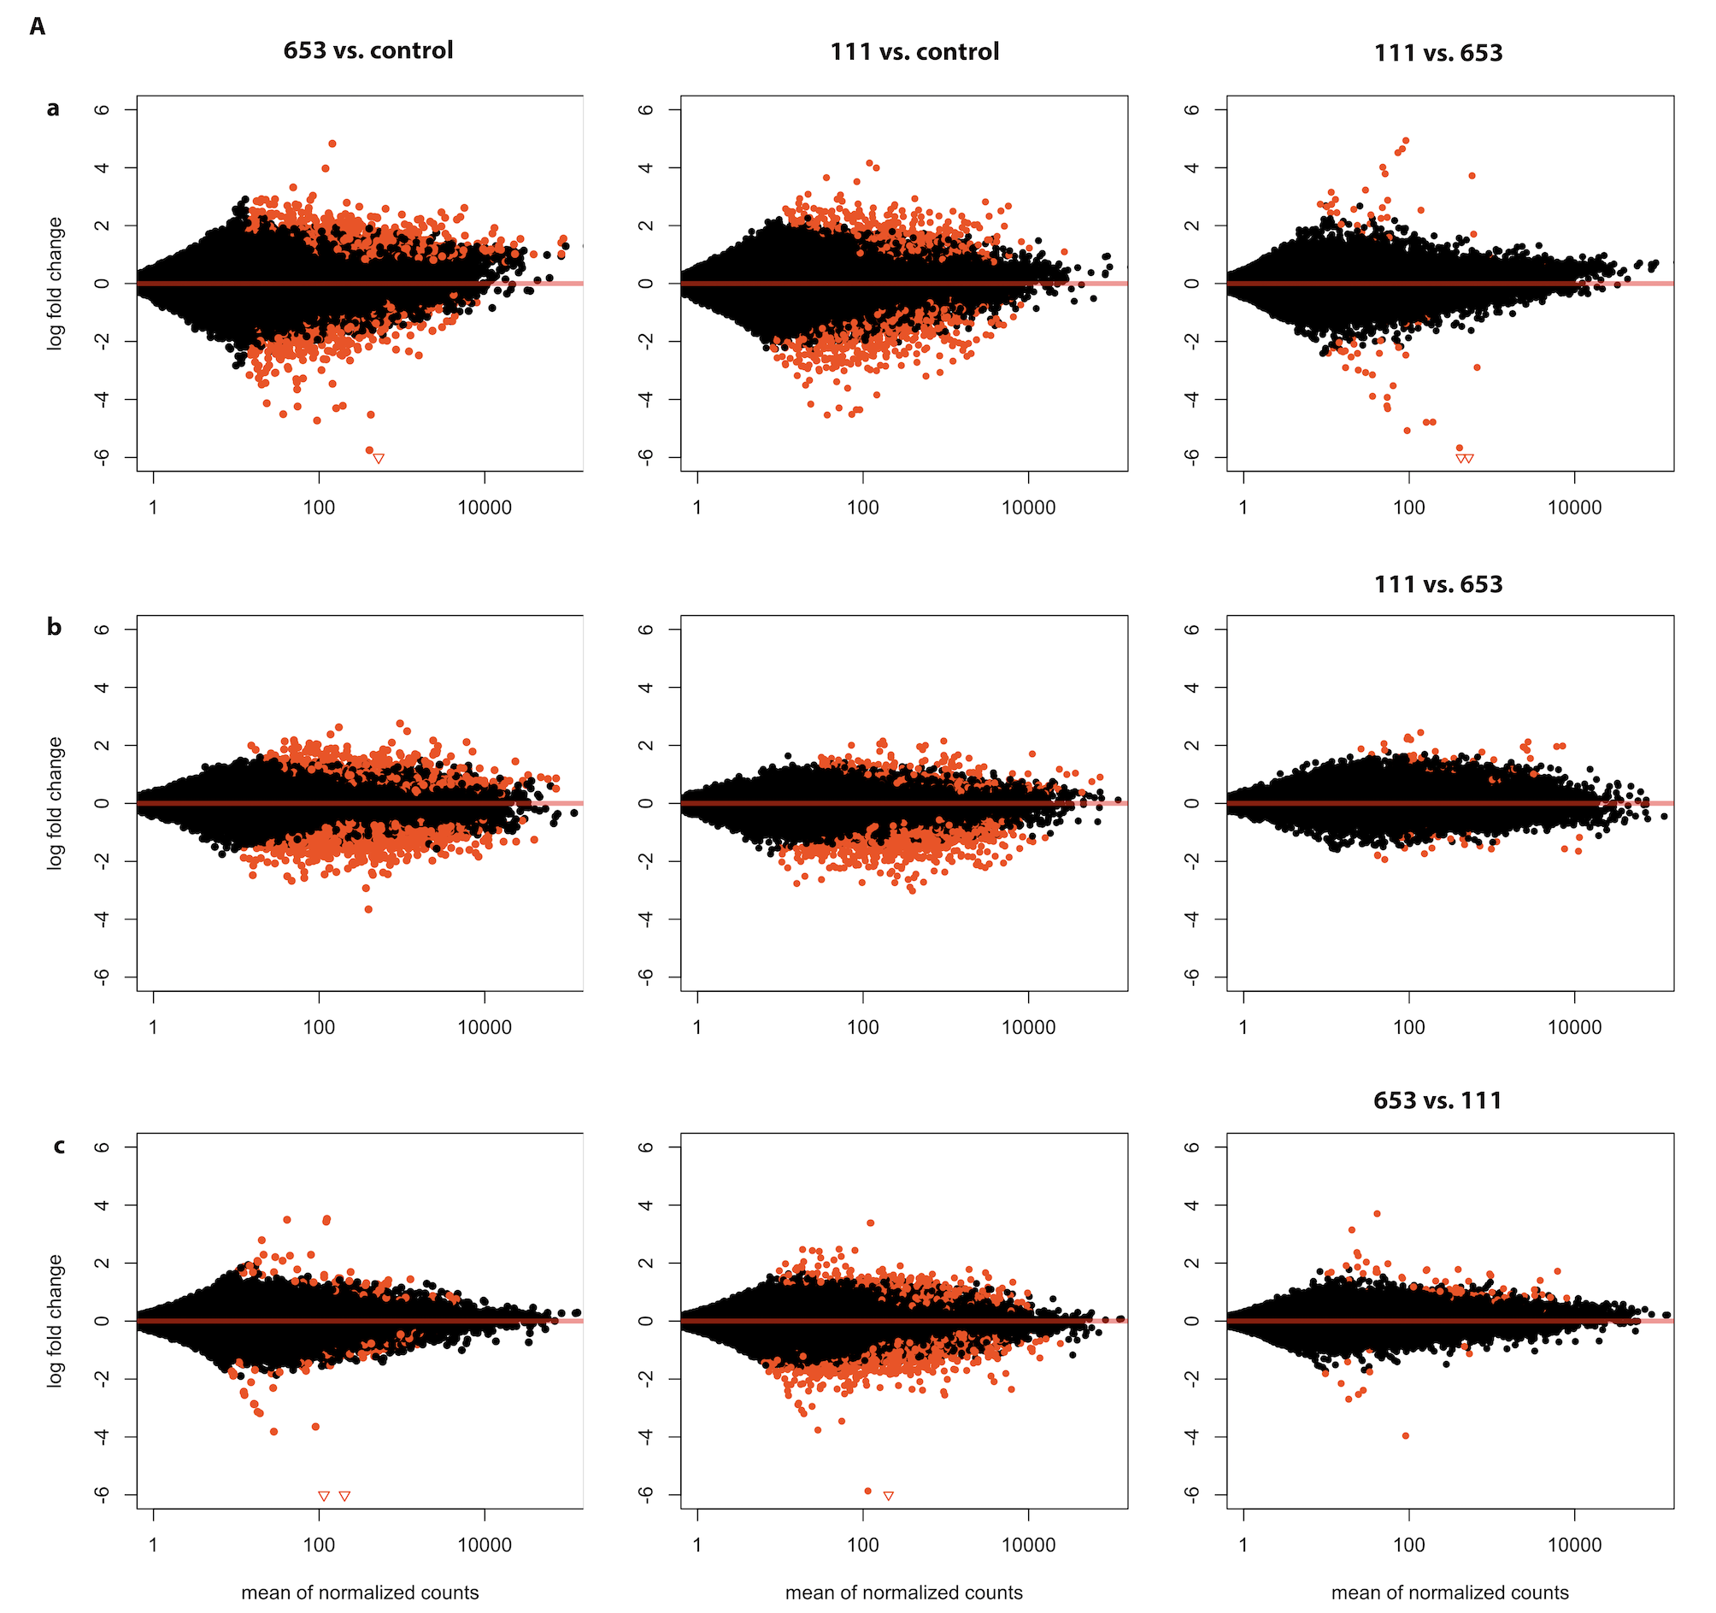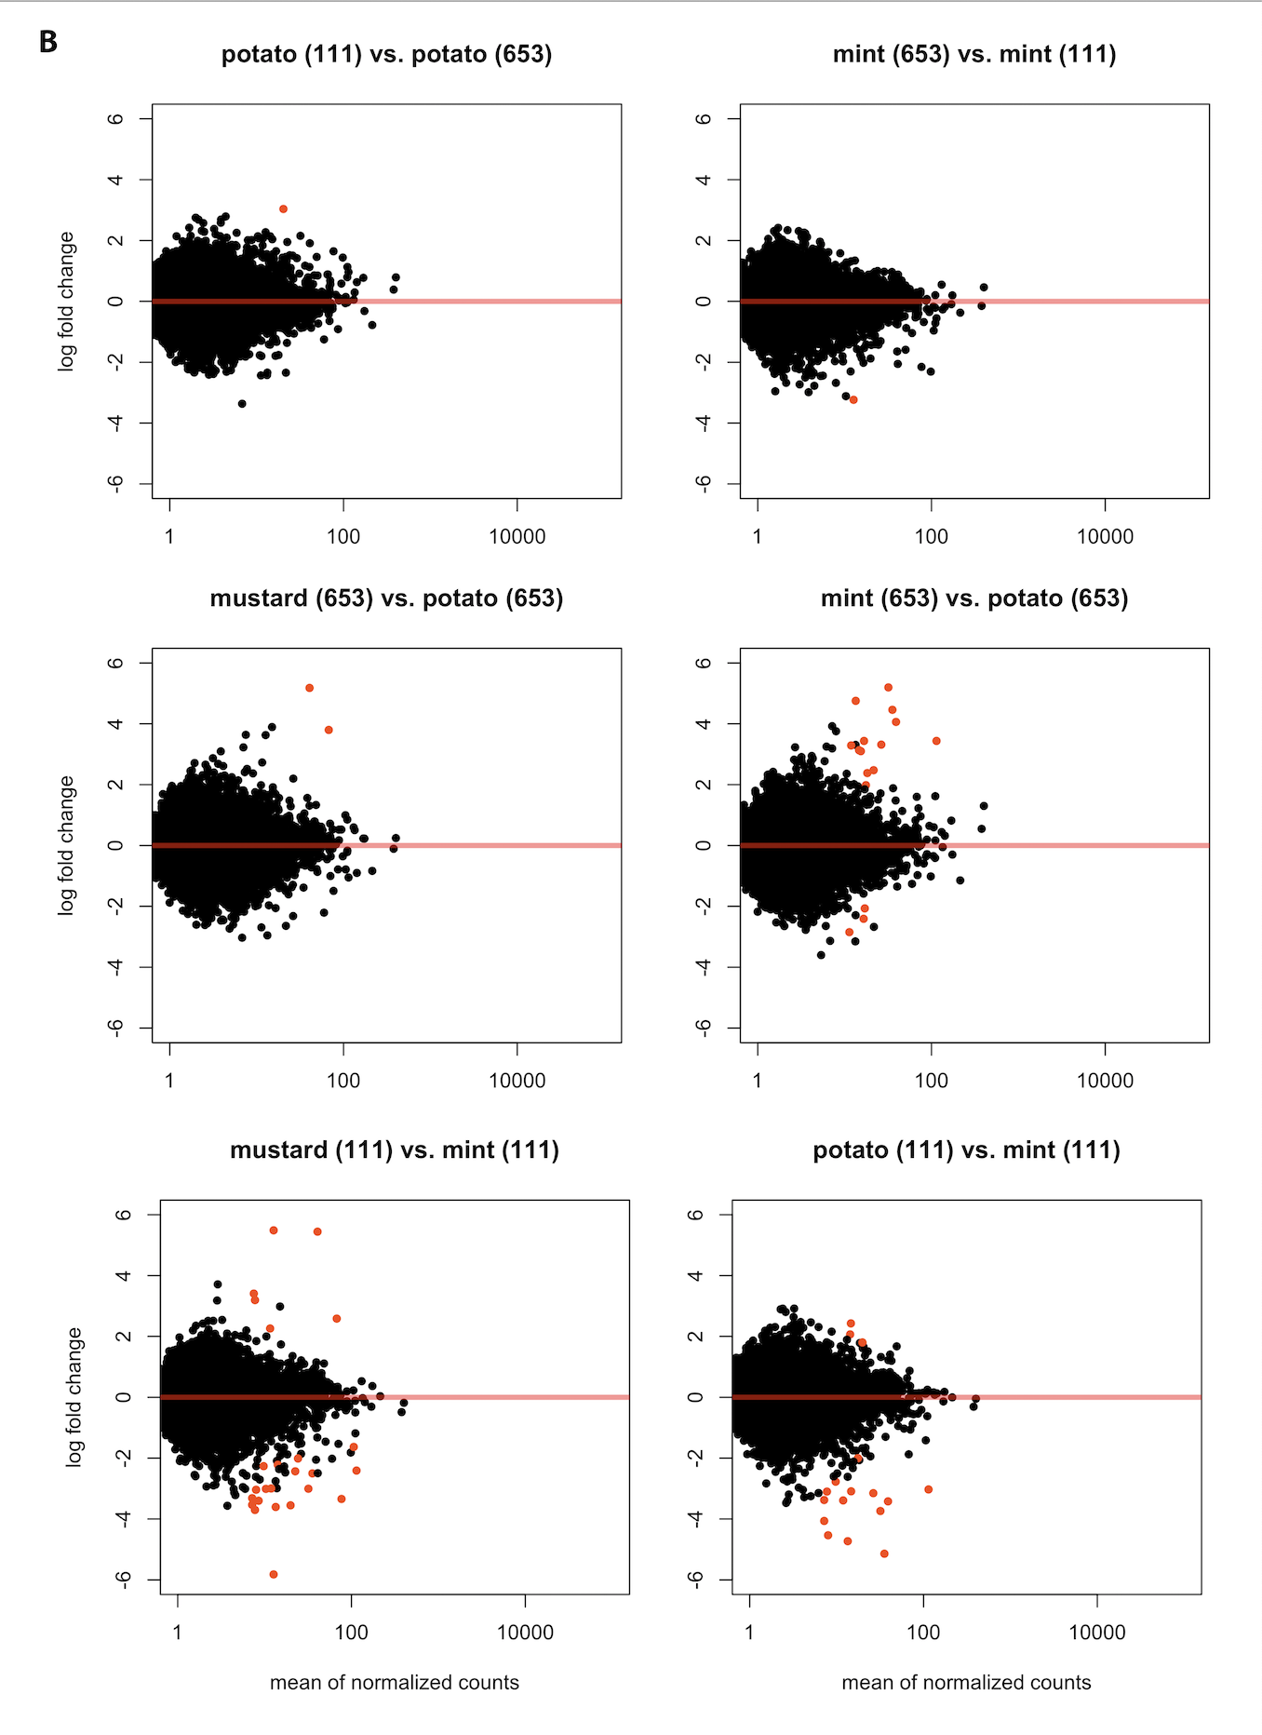

**Figure 3.** Heatmaps for the top 20 differentially expressed genes (DEG) for (a) brown mustard, (b) potato, (c) peppermint, and (d) Verticillium dahliae.DEGs are clustered with *k-*means by rows. Columns represent treatments. DEGs without recognizable gene names were not homologous to genes from online repositories. Each cell represents a biological replicate. The color of each cell reflects the relative changes in gene expression illustrated in the legends.

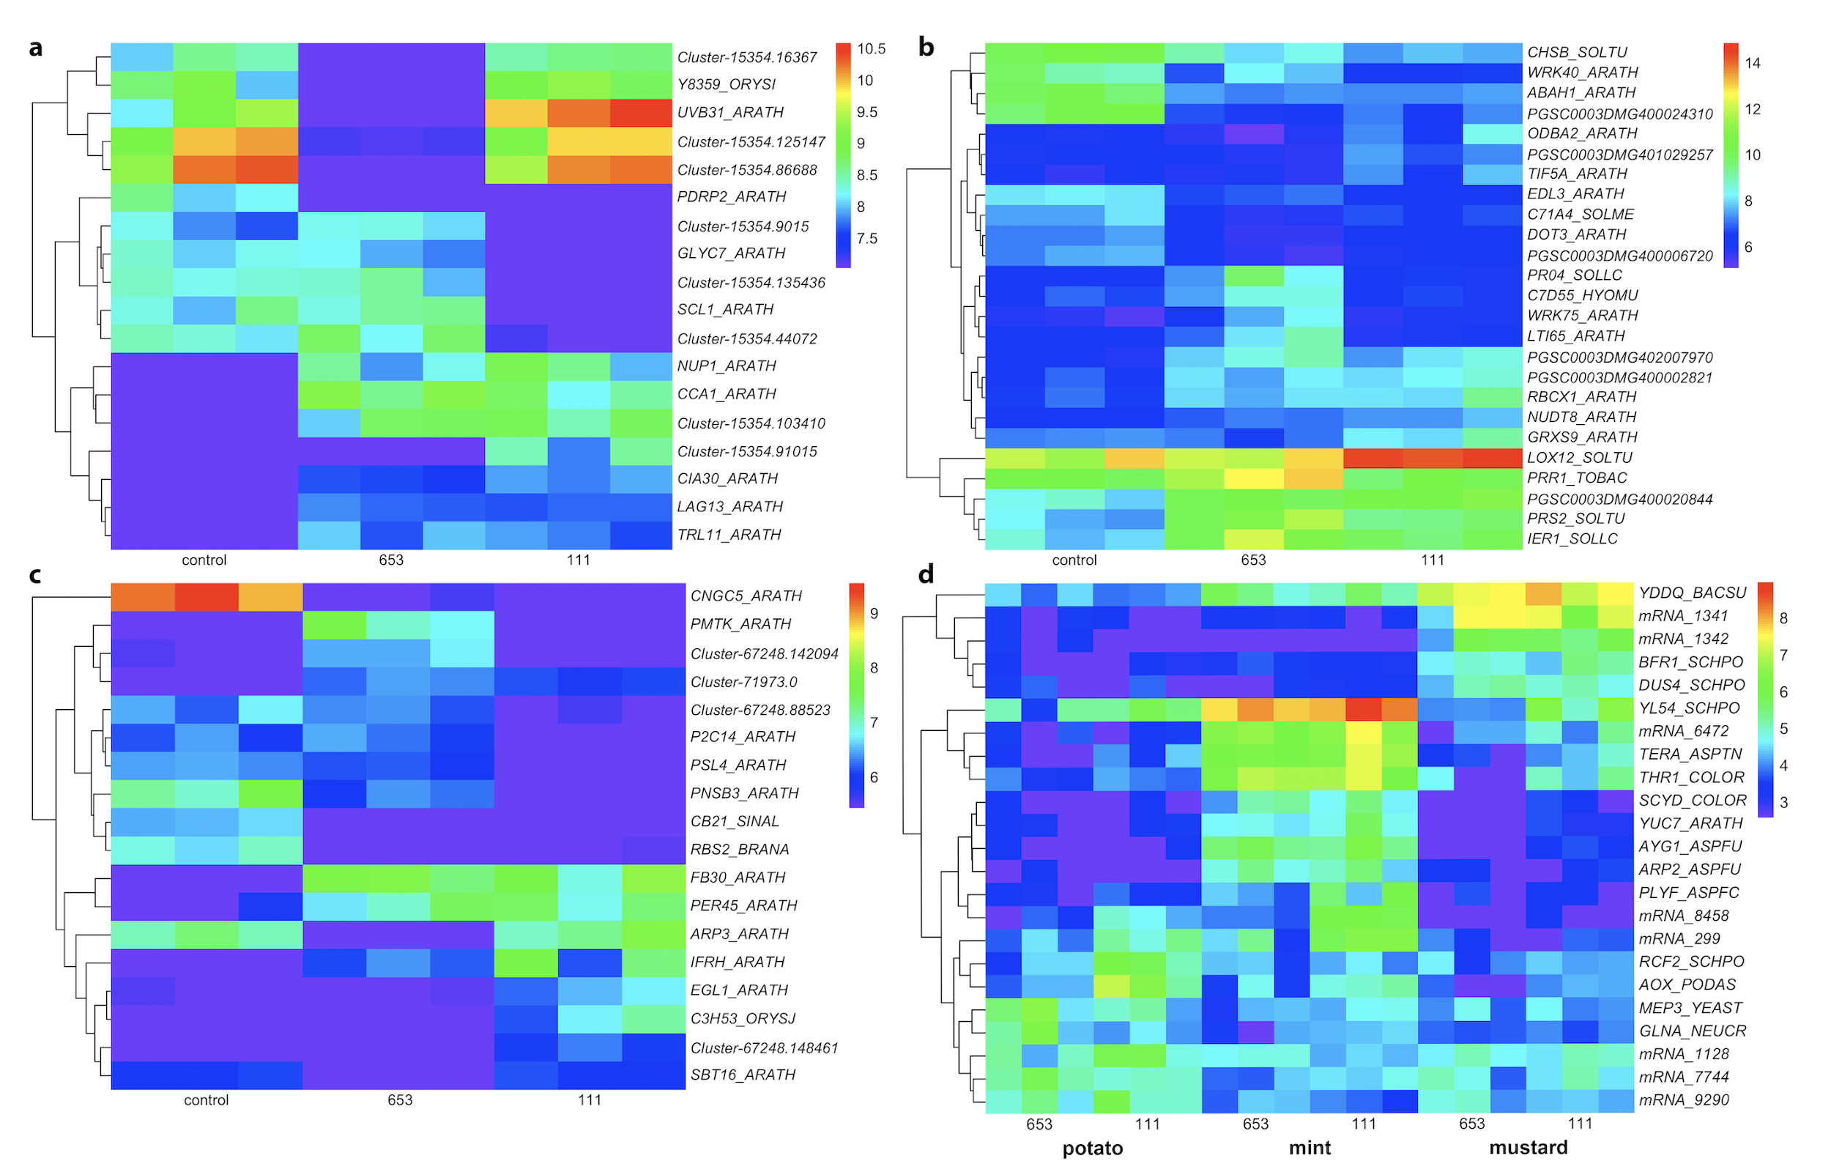

**Figure 4.** Volcano plots for (**A**) brown mustard (a), potato (b), and peppermint (c) and (**B**) *Verticillium dahliae.*  Log-transformed *P*-values are expressed as a function of the fold-change between comparisons of interest. Panel **A** illustrates comparisons between *V. dahliae* isolate 653 vs. non-inoculated control, *V. dahliae* isolate 111 vs. non-inoculated control, and between both *V. dahliae* isolates. Panel **B** illustrates comparisons between *V. dahliae* isolates within a host and between hosts within an isolate. Black dots represent genes with relatively small fold-changes and large, non-significant, *P*-values. Yellow dots represent genes with relatively large fold-changes but large, non-significant, *P*-values. Grey dots represent genes with relatively small fold-changes but small *P*-values. Red dots represent genes with relatively large fold-changes and small *P*-values.

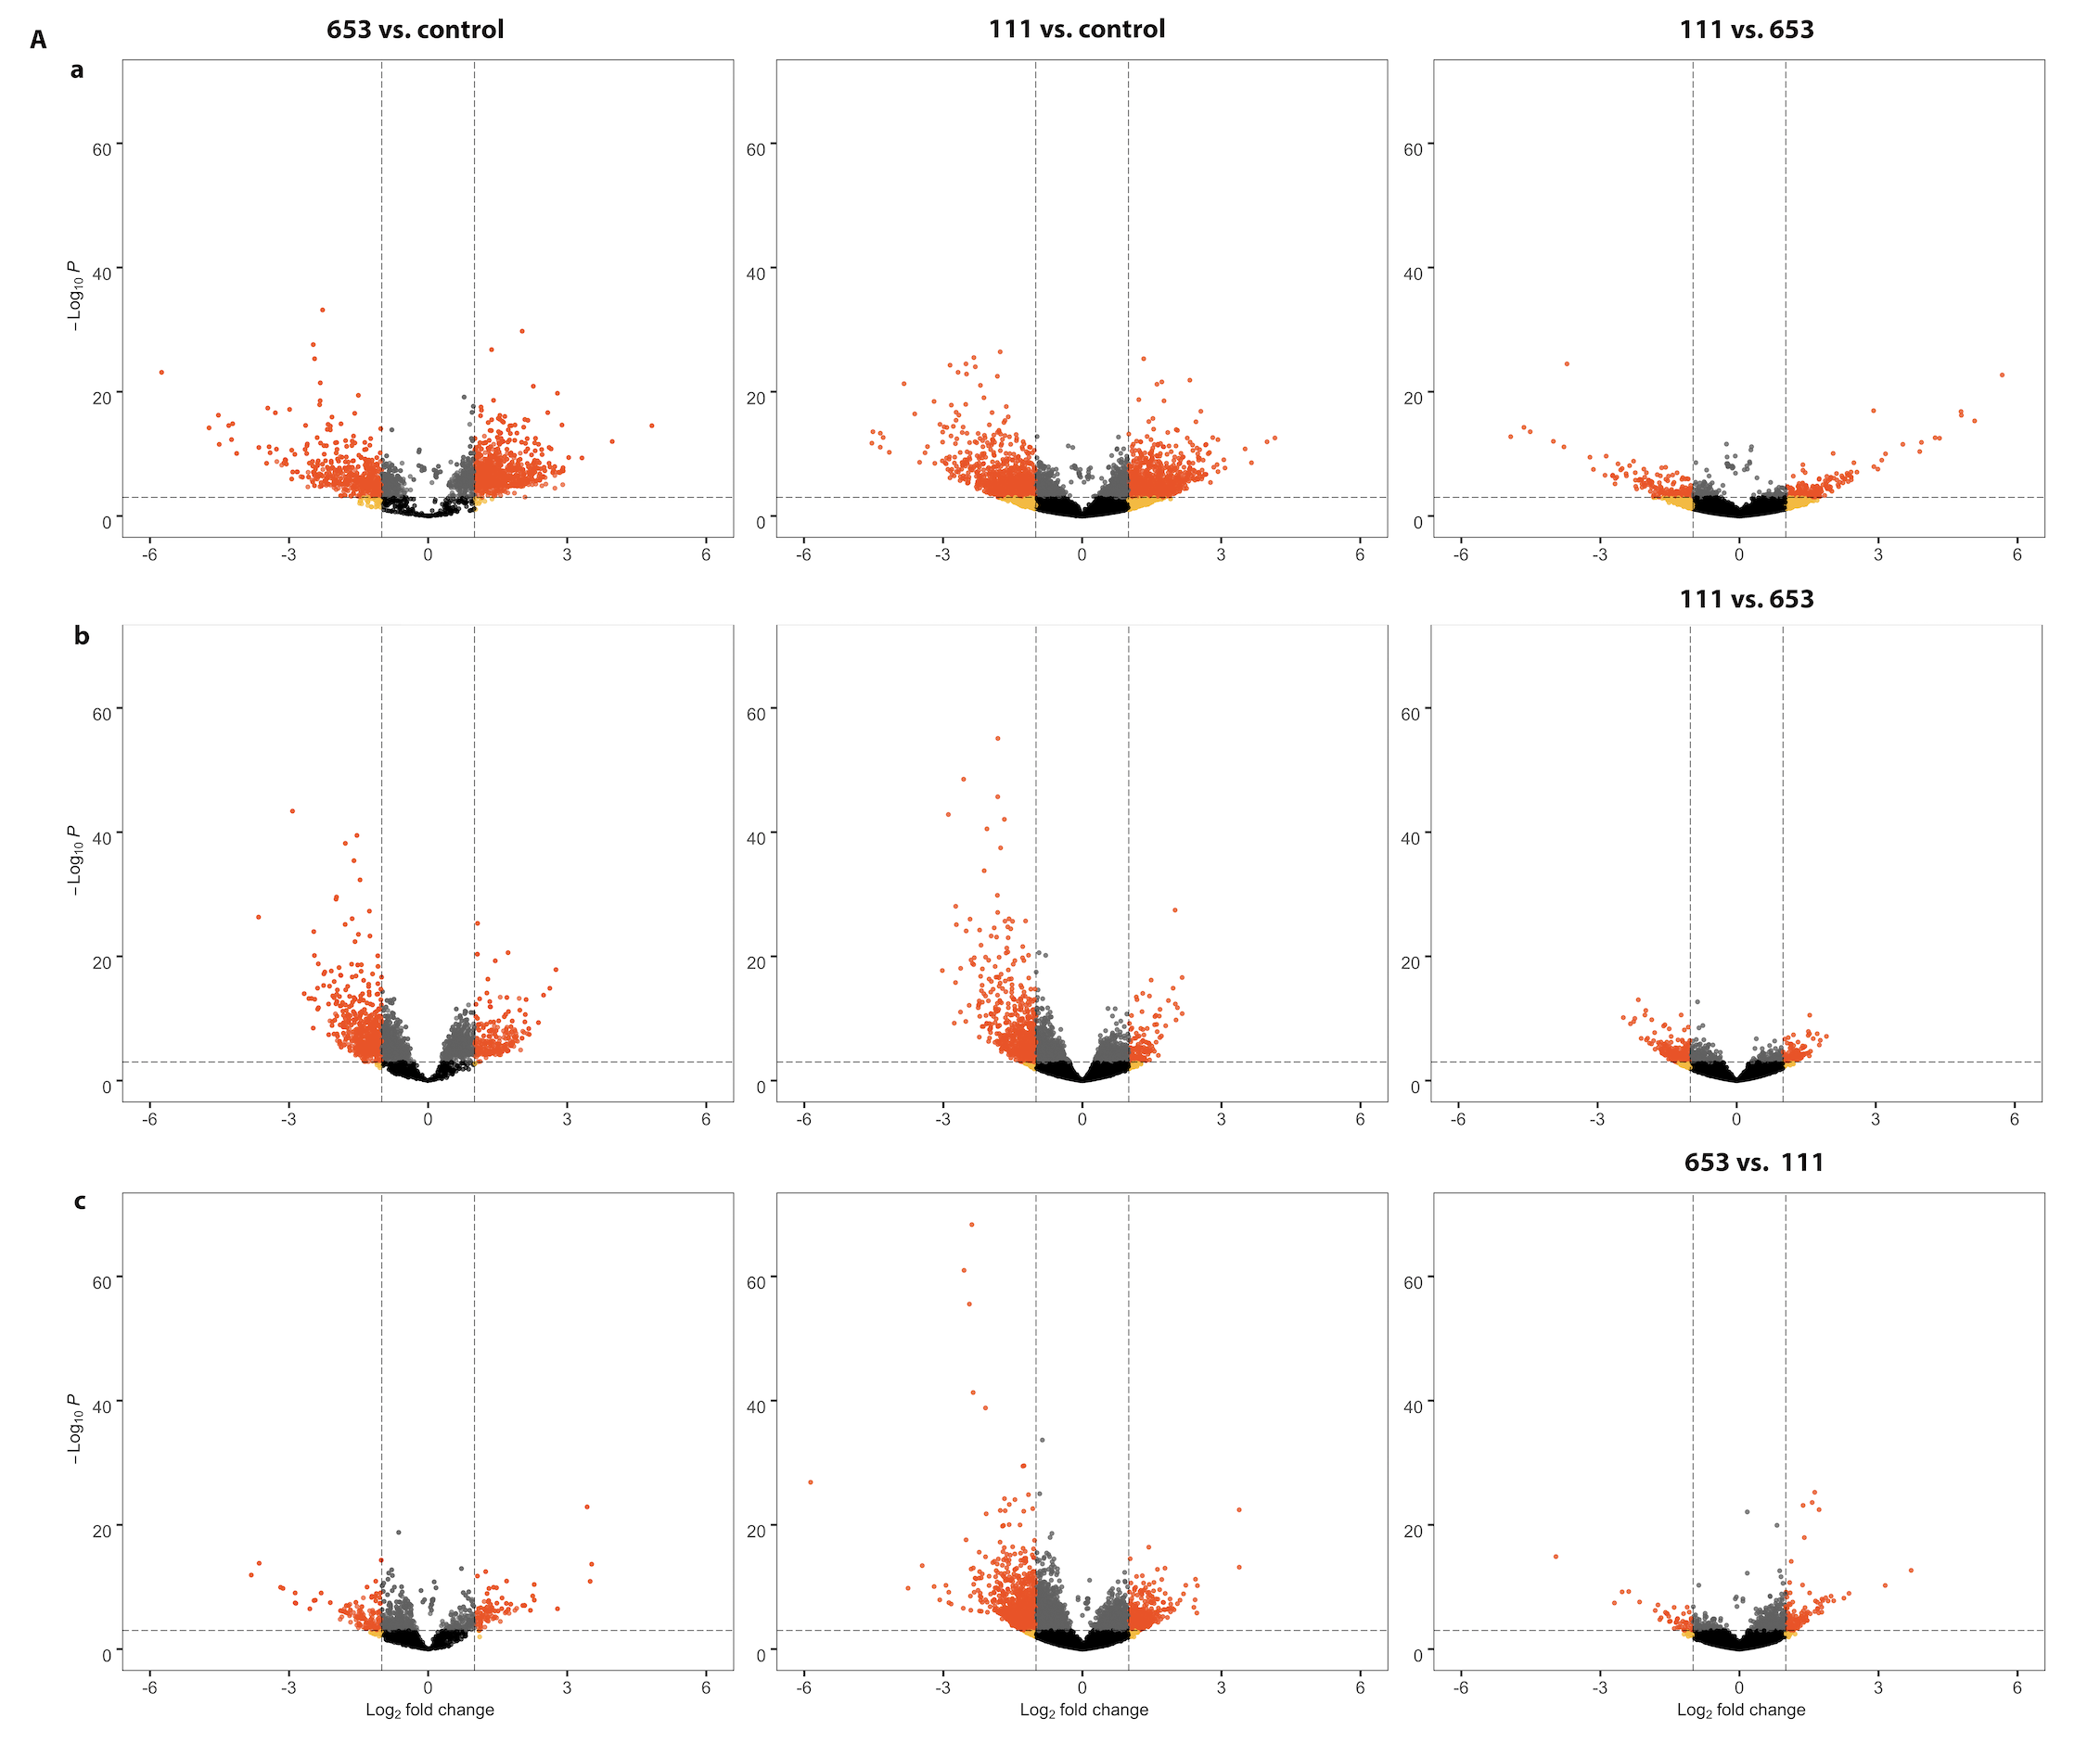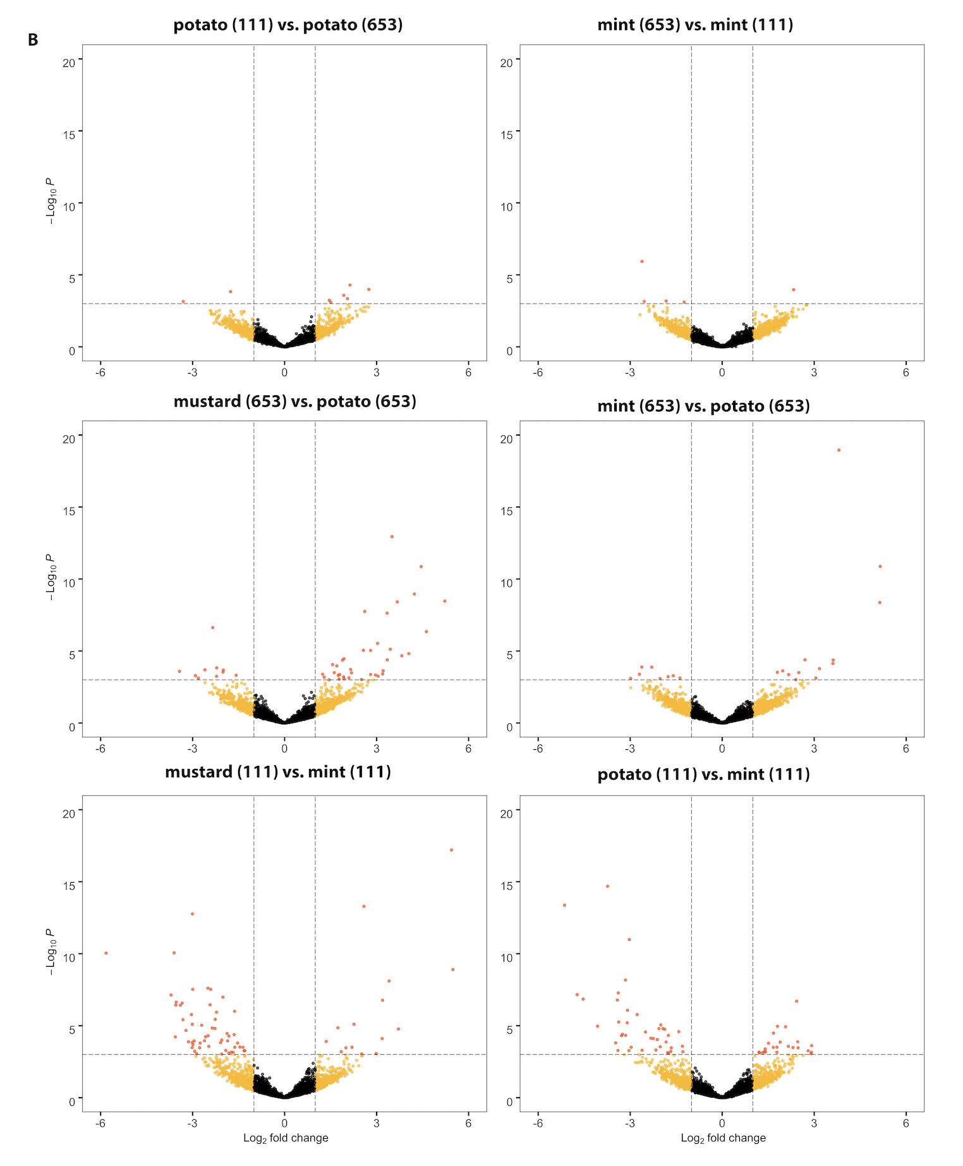

**Figure 5.** Gene ontology of genes detected from brown mustard (a), potato (b), peppermint (c), and *Verticillium dahliae* (d). The number of genes is expressed as a function of their role in biological processes (red), cellular components (green), and molecular functions (blue).

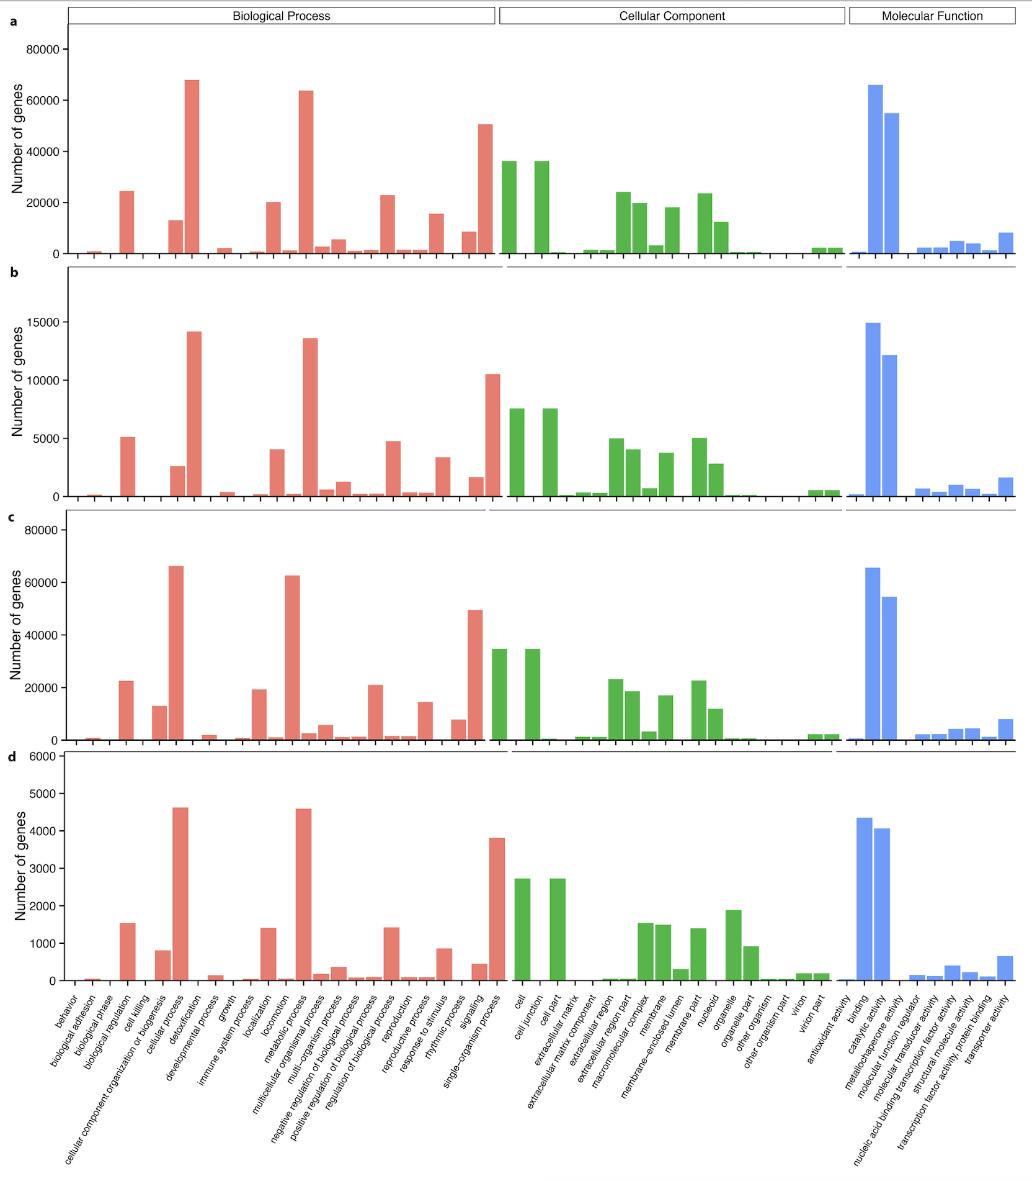

**References**

1. Altschul SF, Gish W, Miller W, Myers EW, Lipman DJ. 1990. Basic local alignment search tool. J Mol Biol. 215(3):403–10.
2. Berlanger I, Powelson ML. 2000. Verticillium wilt. The plant health instructor. [WWW document] URL <https://www.apsnet.org/edcenter/intropp/lessons/fungi/ascomycetes/Pages/VerticilliumWilt.aspx> [accessed on 18 March 2020].
3. Buchfink B, Xie C. and Huson D. 2015. Fast and sensitive protein alignment using DIAMOND. *Nat Methods* 12, 59–60. https://doi.org/10.1038/nmeth.3176.
4. Davidson, N.M., Oshlack, A. Corset: enabling differential gene expression analysis for *de novo* assembled transcriptomes. *Genome Biol* 15, 410 (2014). https://doi.org/10.1186/s13059-014-0410-6.
5. Dung JKS, Schroeder BK, and Johnson DA. 2010. Evaluation of Verticillium wilt resistance in Mentha arvensis and M. longifolia genotypes. Plant Dis. 94:1255-1260.
6. Duressa D, Anchieta A, Chen D, Klimes A, Garcia-Pedraja MD, Dobinson KF, and Klosterman SJ. 2013. RNA-seq analyses of gene expression in the microsclerotia of *Verticillium dahliae*. BMC Genomics. 14, 607. <https://doi.org/10.1186/1471-2164-14-607>.
7. Eddy SR. Accelerated Profile HMM Searches. 2011. PLoS Comput Biol. 10;7(10):e1002195.
8. Götz S, García-Gómez J M, Terol J, et al. 2008. High-throughput functional annotation and data mining with the Blast2GO suite. Nucleic Acids Research 36, 3420-3435.
9. Grabherr M G, Haas B J, Yassour M, et al. 2011. Full-length transcriptome assembly from RNA-Seq data without a reference genome. Nature Biotechnology 29, 644-652.
10. Guo S, Zuo Y, Zhang Y, Wu C, Su W, Jin W, Yu H, An Y, and Li Q. 2017 Large-scale transcriptome comparison of sunflower genes responsive to Verticillium dahliae.BMC Genomics.18:42. doi:10.1186/s12864-016-3386-7.
11. Jiménez-Ruiz J, Leyva-Pérez MO, Gómez-Lama Cabanás C, Barroso JB, Luque F, Mercado-Blanco J. 2019. The Transcriptome of *Verticillium dahliae* Responds Differentially Depending on the Disease Susceptibility Level of the Olive (*Olea europaea* L.) Cultivar. Genes*. 10*, 251.
12. Jin L, Chen D, Liao S. *et al.* 2019. Transcriptome analysis reveals downregulation of virulence-associated genes expression in a low virulence *Verticillium dahliae* strain. Arch Microbiol. 201, 927–941. https://doi.org/10.1007/s00203-019-01663-7
13. Johnson DA and Dung JKS. 2010. Verticillium wilt of potato - The pathogen, disease and management. Can. J. Plant Pathol. 32:58-67.
14. Klosterman SJ, Subbarao KV, Kang S, Veronese P, Gold SE, Thomma BPHJ, et al. 2011. Comparative Genomics Yields Insights into Niche Adaptation of Plant Vascular Wilt Pathogens. PLoS Pathog 7(7): e1002137. https://doi.org/10.1371/journal.ppat.1002137
15. Kumar, GNM, Iyer S, Knowles NR. 2007. Extraction of RNA from Fresh, Frozen, and Lyophilized Tuber and Root Tissues. Journal of Agricultural and Food Chemistry. 55: 1674-1678. Doi: 10.1021/jf062941m
16. Langmead B, and Salzberg SL. 2012. Fast gapped-read alignment with Bowtie 2. Nat Methods. 9(4):357–U354.
17. Love MI, Huber W, and Anders S. 2014. Moderated estimation of fold change and dispersion for RNA-seq data with DESeq2. Genome Biol. 15:550. doi: 10.1186/s13059-014-0550-8.
18. Malcolm GM, Kuldau GA, Gugino BK, and Jiménez-Gasco MM. 2013. Hidden host plant associations of soilborne fungal pathogens: An ecological perspective. Phytopathology 103:538-544.
19. Moriya, Y, Itoh M, Okuda S, Yoshizawa A, and Kanehisa M. 2007. KAAS: an automatic genome annotation and pathway reconstruction server. Nucleic Acids Res. 35, W182-W185.
20. Pegg, G. F., and Brady, B. L. 2002. Verticillium Wilts. CABI Publishing, Wallingford, Oxon, UK.
21. R Core Team. 2019. R: A language and environment for statistical

computing. R Foundation for Statistical Computing, Vienna, Austria.

URL https://www.R-project.org/.

1. Sun Q, Jiang H, Zhu X, Wang W, He X, Shi Y, Yuan Y, Du X and Cai Y. 2013. Analysis of sea-island cotton and upland cotton in response to *Verticillium dahliae* infection by RNA sequencing. BMC Genomics 14, 852. <https://doi.org/10.1186/1471-2164-14-852>.
2. Scholz SS, Schmidt-Heck W, Guthke R, Furch ACU, Reichelt M, Gershenzon J and Oelmüller R. 2018. *Verticillium dahliae-Arabidopsis* Interaction Causes Changes in Gene Expression Profiles and Jasmonate Levels on Different Time Scales. Front. Microbiol. 9:217. doi: 10.3389/fmicb.2018.00217.
3. Trapnell C, Williams B, Pertea G. *et al.* 2010. Transcript assembly and quantification by RNA-Seq reveals unannotated transcripts and isoform switching during cell differentiation. *Nat Biotechnol* 28, 511–515. https://doi.org/10.1038/nbt.1621
4. Tan G, Liu K, Kang J, Xu K, Zhang Y, Lizong H, Zhang J, Li C. 2015. Transcriptome analysis of the compatible interaction of tomato with *Verticillium dahliae*. Frontiers in Plant Science. 6:428. <https://doi.org/10.3389/fpls.2015.00428>
5. Tsror L, Shlevin E, and Peretz-Alon I. 2005. Efficacy of metam sodium for controlling*Verticillium dahliae* prior to potato production in sandy soils. Am. J. Pot Res*.* 82, 419–423.
6. Wheeler DL and Johnson DA. 2016. *Verticillium dahliae* infects, alters biomass, and produces inoculum on rotation crops. Phytopathology. 106:602-613.
7. Wheeler DL, Dung JKS, and Johnson DA. 2018. From pathogen to endophyte: emergence of an endophytic population of *Verticillium dahliae* in rotation crops from a sympatric population associated with wilted potatoes. New Phytologist. 222: 497-510.<https://doi.org/10.1111/nph.15567>
8. Wilhelm S. 1955. Longevity of Verticillium wilt fungus in the laboratory and field. Phytopathology 45:180-181.
9. [Woodward JE, Wheeler](https://apsjournals.apsnet.org/doi/10.1094/PHP-2011-0323-02-RS#) TA, [Cattaneo](https://apsjournals.apsnet.org/doi/10.1094/PHP-2011-0323-02-RS#) MG, [Russell](https://apsjournals.apsnet.org/doi/10.1094/PHP-2011-0323-02-RS#) SA, and [Baughman](https://apsjournals.apsnet.org/doi/10.1094/PHP-2011-0323-02-RS#) TA. 2011. Evaluation of Soil Fumigants for Management of Verticillium Wilt of Peanut in Texas. Plant Health Progress.12. <https://doi.org/10.1094/PHP-2011-0323-02-RS>
10. Xu X, Pan S, Cheng S. *et al.* 2011. Genome sequence and analysis of the tuber crop potato. *Nature* 475, 189–195. https://doi.org/10.1038/nature10158

**Garbagio**

Gene expression levels for potato and *V. dahliae* were determined with the expected fragments per kilobase of transcript per million fragments mapped (FPKM) (Trapnell *et al.* 2010). For peppermint and brown mustard, the abundance of reads were estimated with RNA-seq by Expectation-Maximization (RSEM) with Bowtie 2 (Langmead *et al.* 2012). FPKM was then used to calculate expression gene expression levels. DEGs were identified with the DESeq2 package version 1.26.0 (Love *et al.* 2014) in R version 3.6.2 (R Core Team (2019)).